Enlist 2020

**1 Filter**

1.1 Parameters

Southcentral and Southwest failed to converge.

1.1.1 Southwest

## Model fitted: Log-logistic (ED50 as parameter) with lower limit at 0 (3 parms)  
##   
## Parameter estimates:  
##   
## Estimate Std. Error t-value p-value   
## b:(Intercept) 8.78651 3.67777 2.3891 0.09682 .  
## d:(Intercept) 1201.32111 703.66859 1.7072 0.18632   
## e:(Intercept) 0.89917 0.25491 3.5274 0.03871 *  
## ---  
## Signif. codes: 0 '***' 0.001 '**' 0.01 '*' 0.05 '.' 0.1 ' ' 1  
##   
## Residual standard error:  
##   
## 3.329187 (3 degrees of freedom)

1.1.2 Northcentral

##   
## Model fitted: Log-logistic (ED50 as parameter) with lower limit at 0 (3 parms)  
##   
## Parameter estimates:  
##   
## Estimate Std. Error t-value p-value  
## b:(Intercept) 4.8309e-03 1.6776e+00 0.0029 0.9979  
## d:(Intercept) 6.7663e-02 1.5002e+00 0.0451 0.9669  
## e:(Intercept) 5.7490e-01 5.3036e+03 0.0001 0.9999  
##   
## Residual standard error:  
##   
## 0.08216097 (3 degrees of freedom)

1.2 ED50 and ED99

1.2.1 Southwest

##   
## Estimated effective doses  
##   
## Estimate Std. Error  
## e:1:50 0.89917 0.25491  
## e:1:99 1.51694 0.11182

1.2.2 Northcentral

## Estimated effective doses  
##   
## Estimate Std. Error  
## e:1:50 0.5749 5303.5612  
## e:1:99 Inf NA

1.3 Figure

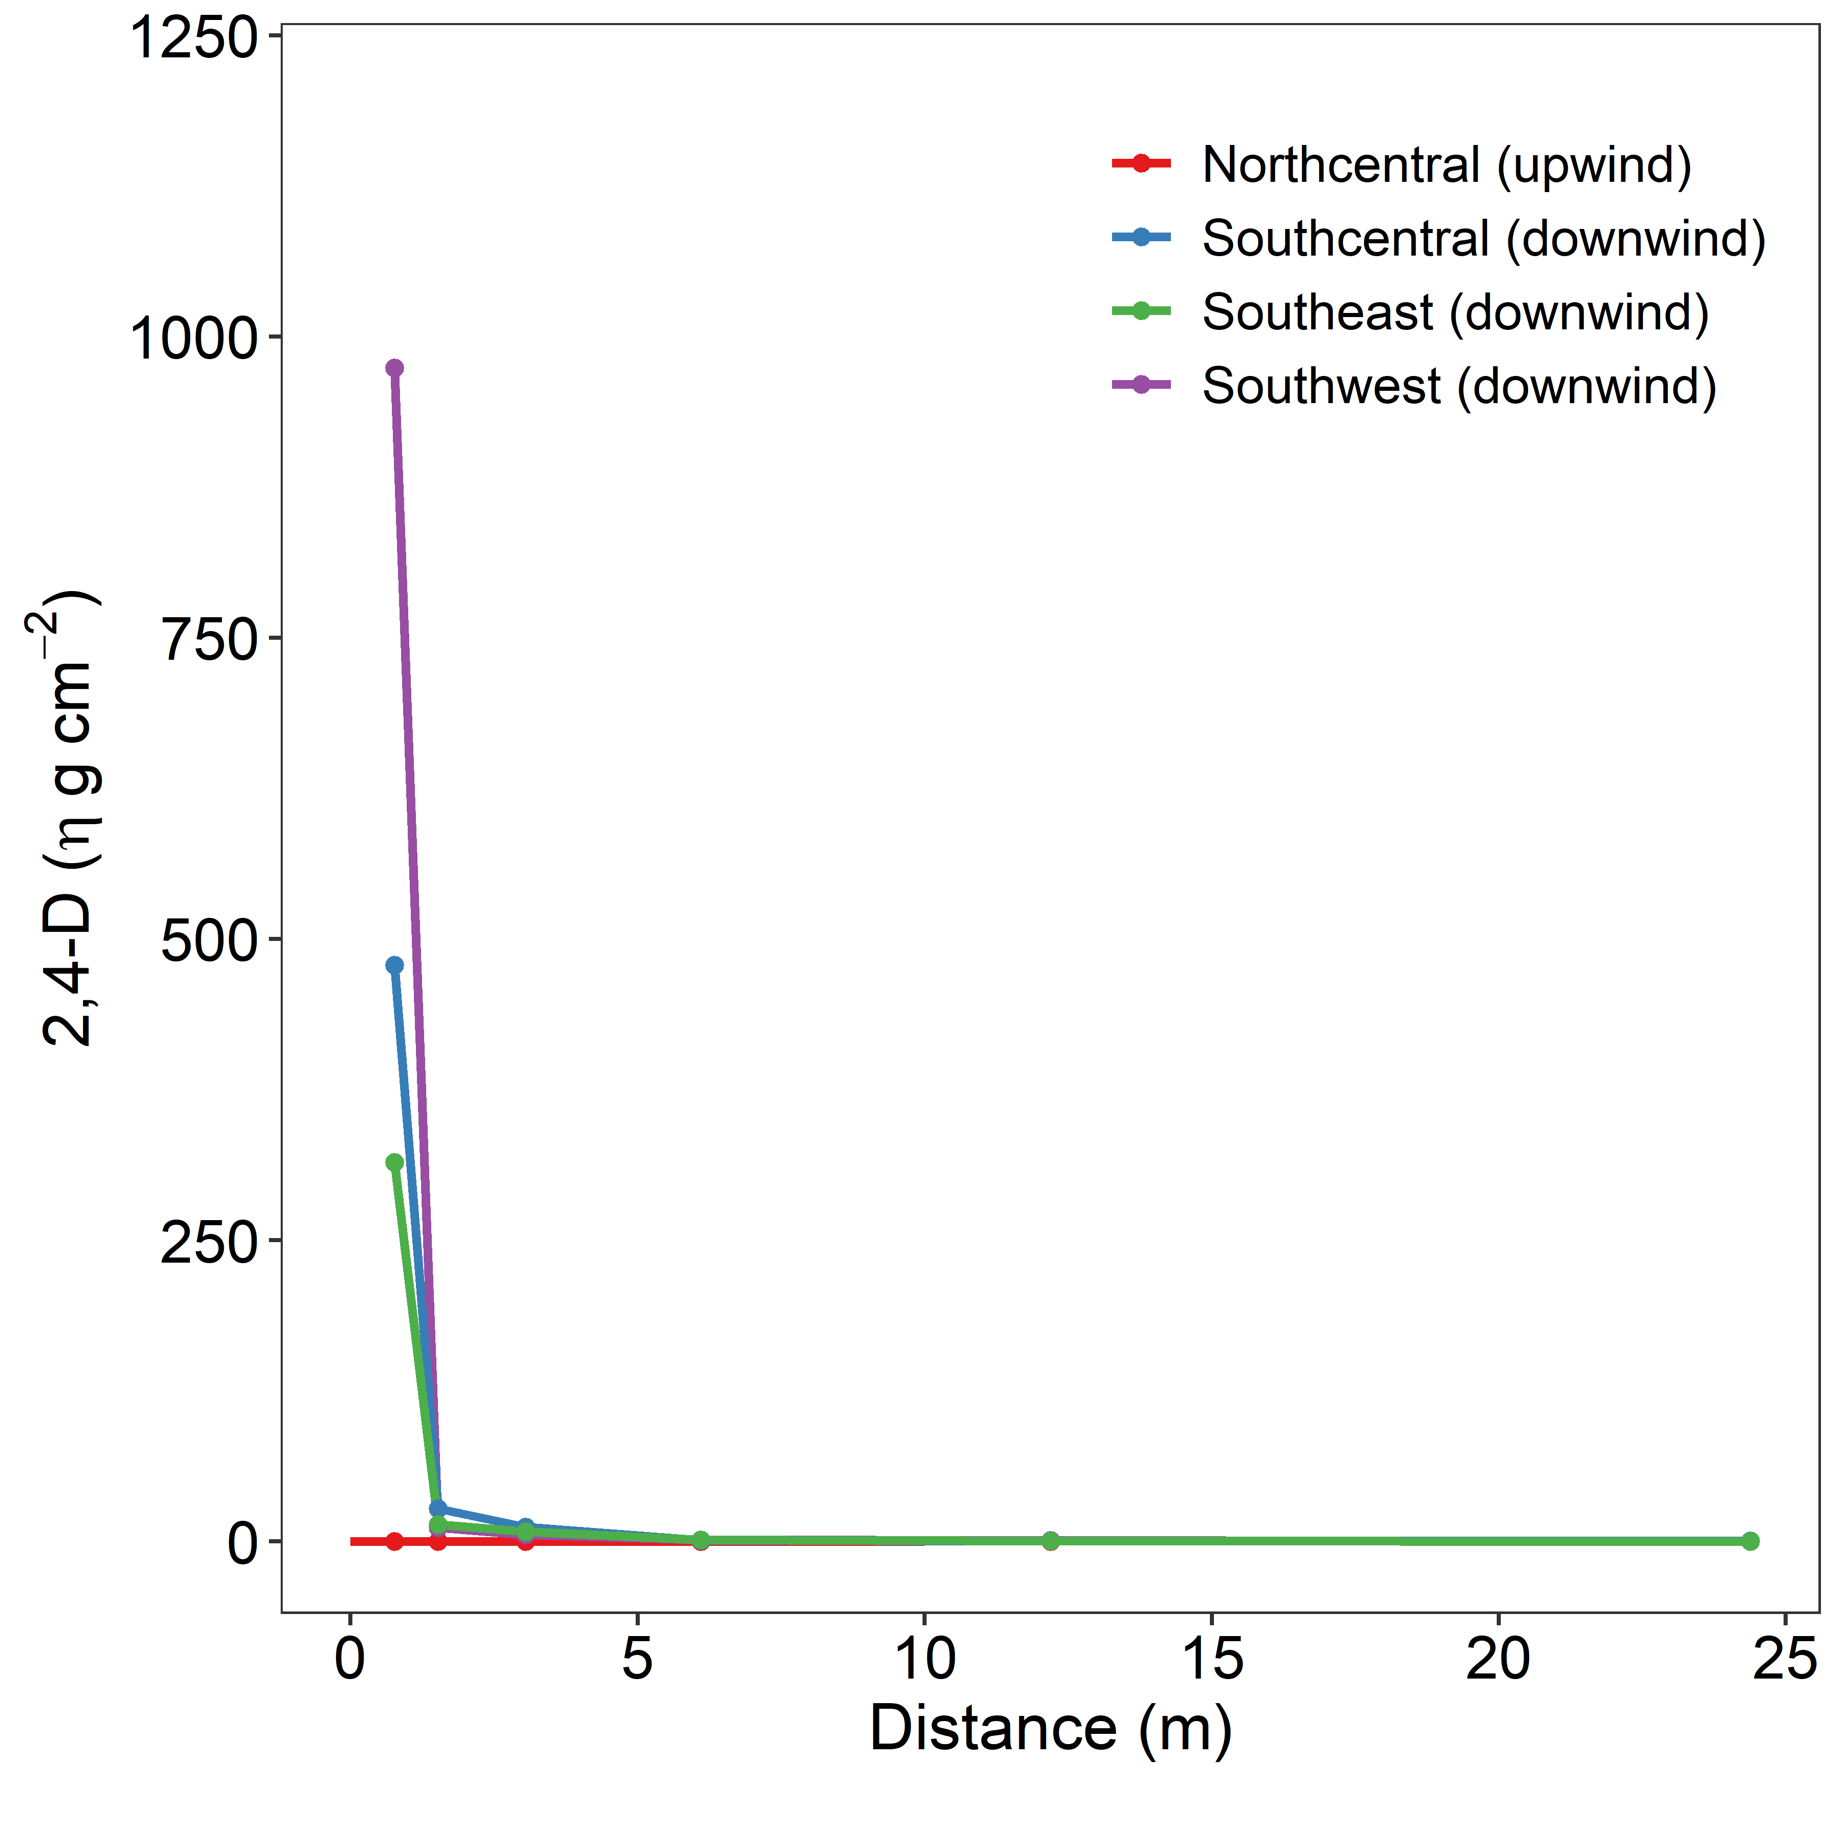

**2 Injury**

2.1 Figure

